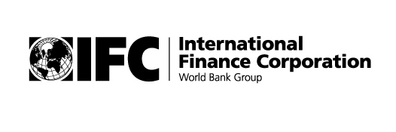
www.publicprivatedialogue.org
Africa Regional Workshop

DEVELOPING A 12-MONTH WORKPLAN FOR IFC-SPONSORED PPDs IN AFRICA
Public-Private Dialogue

Organized by:
James Emery – IFC Investment Climate Team for Africa
Benjamin Herzberg – IFC SME Department BEE Unit

With representatives from:
Burkina Faso
Chad
Cameroon
Central African Republic
Ethiopia
Liberia
Rwanda
Sierra Leone
Sudan
Participants List

Burkina Faso
Gilles Yameogo, Legal and Institutional Development Specialist
Doing Business Better in Burkina Faso Program

Cameroon
Christian Ekoka
Consultant, Cameroon Business Forum

Central African Republic
Robert Amedi, Sécretaire Générale
Steve Tangoa, Sécretaire Générale Adjoint
Cadre Permanent de Concertation Etat-Secteur Privé
Estelle Nguile, Groupement Interprofessionel de Centre Afrique

Chad
N. Yamtebaye, Conseiller
Forum des Affaires du Tchad

C. Kante, Operations Officer
Ferdinand Ngobounan, Associate Operations Officer
IFC PEP Africa

Ethiopia
Hagos Aregay, Director, Office of Public-Private Partnerships
Ministry of Trade and Industry

Liberia
Maria Miller, Consultant
Nana Yaa Ofori-Atta, Communications Advisor
IFC Investment Climate Team for Africa

Rwanda
Emmanuel Hategeka, Executive Secretary
Rwanda Private Sector Federation

Sierra Leone
Oluniyi Robbin-Coker, Executive Director
I. S. Kamara, Economist
Sierra Leone Business Forum

Sudan
Maisoun Badawi, PSD Advisor
Kenyi Spencer, Consultant
World Bank Private Sector Development Unit

IFC Investment Climate Team for Africa
Mary Agboli, Sarah Kitakule

